$111,000.00
HOLZWORTH-BEGEMAN
404 8TH ST WEST, MOBRIDGE
MOBRIDGE NWTS 1ST ADDN E 70’ OF LOTS 7 & 8 BLOCK 18
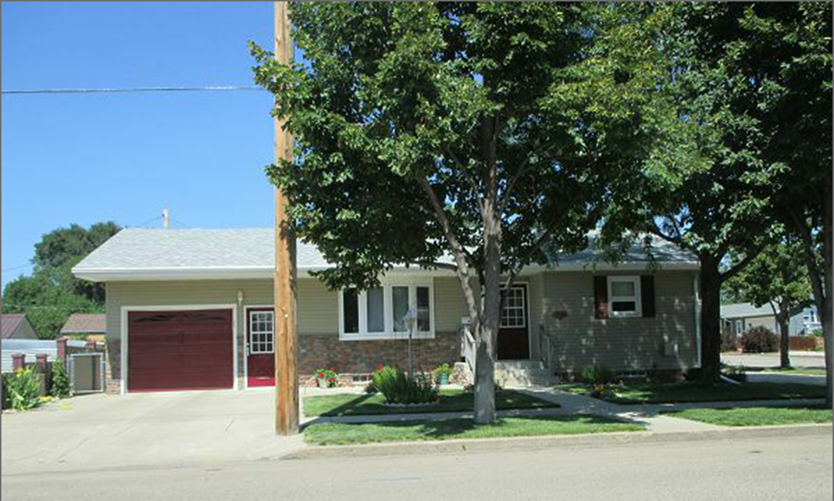
RECORD #5980
LOT SIZE 70’ X 70’ GROUND FLOOR 992 SQ FT
SINGLE FAMILY ONE STORY 2 BEDROOMS ABOVE
GOOD QUALITY AND CONDITION 2 BEDROOMS IN BASEMENT
BUILT IN 1965 1 ¾ BATH
2009; NEW COMPOSITE STEPS TO PATIO BSMT 992 SQ FT 496 SQ FT FIN REC
INSTALL EGRESS WINDOWS, REPLACE SIDING GARAGE 992 SQ FT
NEW STONE FACING, REPLACE DECK WOOD DECK 140 SQ FT
INSULATION IN ATTIC $35,000
CENTRAL AIR, CASEMENT VINYL WINDOWS GOOD
SOLD ON 7/27/17 FOR $111,000
ASSESSED IN 2017 AT $99,440 RECORD #5980
ASSESSED IN 2012 AT $54,350

