$8,000.00
RUNNELS-QUENZER
815 3RD AVE WEST, MOBRIDGE
MOBRIDGE NWTS 1ST ADDN S 20’ OF LOT 2 & N 30’ OF LOT 3 BLOCK 12
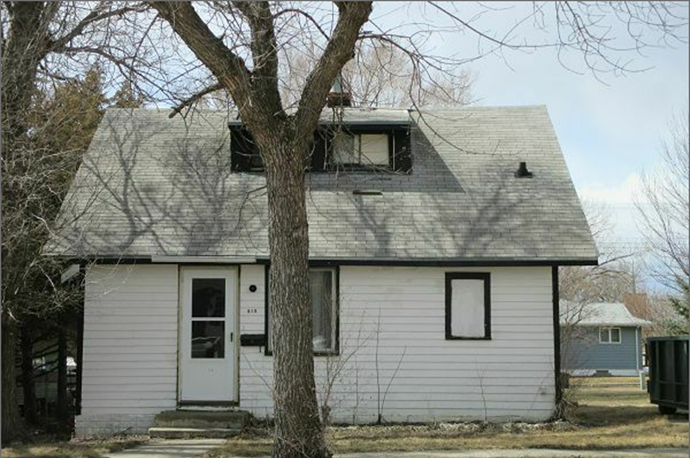
RECORD # 5977

LOT SIZE 50’ X 140’ TOTAL LIVING 904 SQ FT
SINGLE FAMILY & ONE STORY 1 ST FLOOR 688 SQ FT
AVERAGE QUALITY & CONDITION 3 BEDROOMS 1 BATH
BUILT IN 1928 WOOD DECK 10’ X 13’
2014; ROOF GOOD, WINDOWS OLD
SIDING POOR, CRUMBLING CHIMNEY
WOOD DECK ROTTED
SOLD ON 12/22/17 FOR $8,000 RECORD #5977
ASSESSED IN 2017 AT $19,770
ASSESSED IN 2012 AT $18,135

