$140,000.00
CRIPE-HAWK
1021 5TH AVE WEST, MOBRIDGE
MOBRIDGE NWTS 1ST ADDN LOT 1 & N 27.5’ OF LOT 2 BLOCK 4
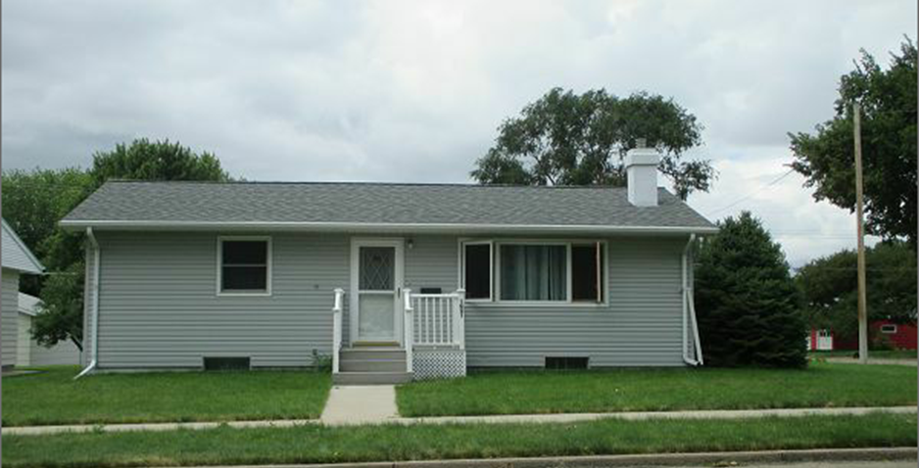
RECORD #5926

LOT SIZE 65’ X 140’ TOTAL LIVING 1292 SQ FT
SINGLE FAMILY ONE STORY 2 BEDROOMS 1 ½ BATHS
AVERAGE QUALITY / CONDITION BASEMENT 912 SQ FT
BUILT IN 1965 BUILT IN DISWASHER
2014; ROOF SHINGLES FAIR ATTACHED GARAGE 540 SQ FT
SMALL COMPOSITE DECK FRONT
2007; STEEL SIDING, CENTRAL AIR NATURAL GAS
CASEMENT/METAL WINDOWS GOOD
SOLD ON 6/5/2017 FOR $140,000 RECORD #5926
ASSESSED IN 2017 AT $134,860
ASSESSED IN 2012 AT $63,590

