$41,000.00
OVERSETH-SHADDUCK
221 4TH AVE EAST, MOBRIDGE
MOBRIDGE-MILW LAND CO’S 2ND ADDN E. 84’ OF LOT 1, BLOCK 29
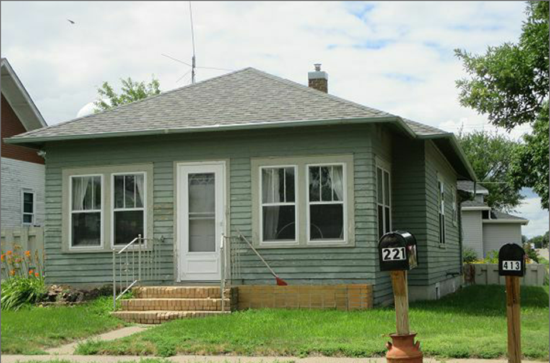
RECORD #5877

LOT SIZE 50’ X 84’ GROUND FLOOR 864 SQ FT
SINGLE FAMILY, ONE STORY 2 BEDROOMS 1 BATH
AVERAGE QUALITY AND CONDITION BASEMENT 864 SQ FT
BUILT IN 1928 500 SQ FT FIN. REC.
2014; OLD CASEMENT/ALUMINUM SOLID WALL PORCH
BRICK PLANTER-STEPS/ POOR
SIDING POOR, FOUNDATION FAIR
CENTRAL AIR, NATURAL GAS
SOLD ON 6/22/2017 FOR $41,000 RECORD #5877
ASSESSED IN 2017 AT $27,000
ASSESSED IN 2012 AT $21,340

