$80,000.00
KENY JENSEN RENTALS-CARLSON SERVICE
413 4TH AVE EAST, MOBRIDGE
MOBRIDGE-MILW LAND CO’S 2ND ADDN LOT 3 BLOCK 27
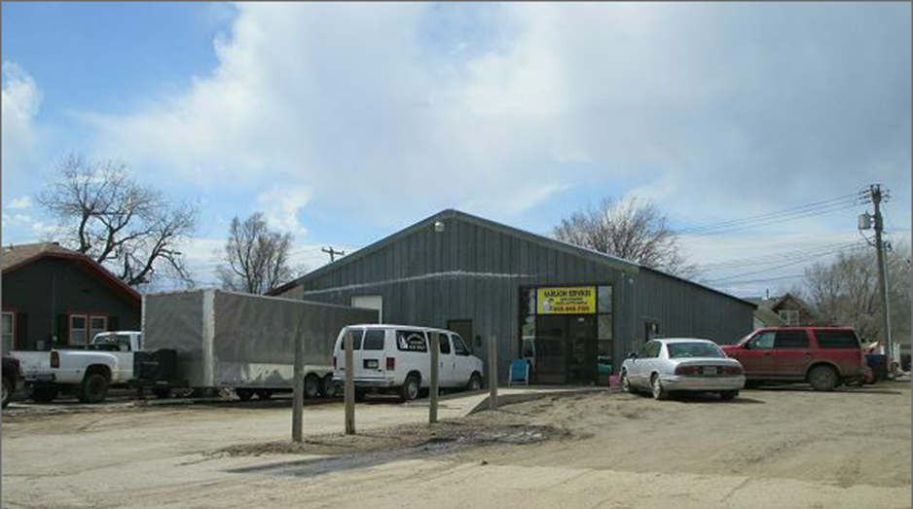
RECORD #5857

LOT SIZE 50’ X 140’ 2660 SQ FT
RETAIL/STORAGE GARAGE
LOW QUALITY WORN CONDITION
BUILT IN 1960
SPACE HEATER
INSULATED
SOLD ON 2/13/18 FOR $80,000
ASSESSED IN 2017 AT $14,005
SOLD IN 2009 FOR $54,000
ASSESSED IN 2012 AT $12,180

