$87,500.00
FUHRMAN-HOLZER
109 3RD AVE EAST, MOBRIDGE
MOBRIDGE MILWAUKEE LAND CO’S 1ST ADDITION N E 100’ OF LOT 4 & ALL OF LOT 4 & ALL LOT 5 BLOCK 16
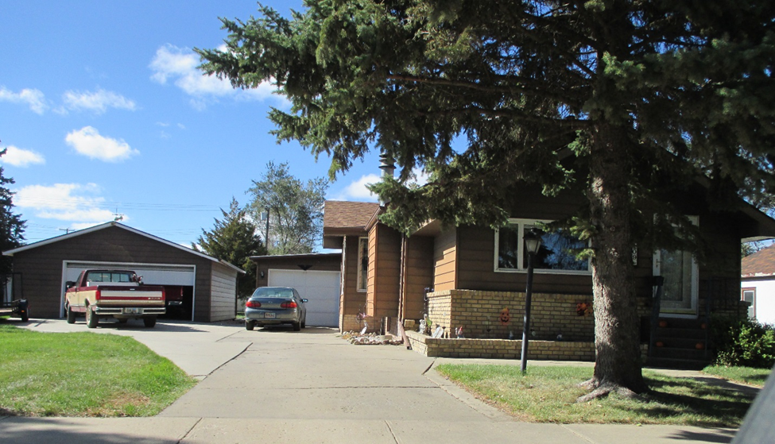
RECORD # 5747

LOT SIZE 50’ X 100’ & 50’ X 40’ TOTAL LIVING 1280 SQ FT
SINGLE FAMILY, ONE STORY,BUILT IN 1920 2 BEDROOMS 1 ¾ BATH
AVERAGE QUALITY AND CONDITION 8 FIXTURES
AVERAGE QUALITY AND CONDITION BASEMENT 844 SQ FT
CENTRAL AIR NATURAL GAS BASEMENT FINISHED 1 BED
2014- BRICK TRIM FRONT, ROOF GOOD ROOFED PORCH 170 SQ FT
VINYL SIDING FRONT & ALL DETACHED GARAGE KNEE WALL PORCH 225 SQ FT
SMALL HOUSE IN REAR USED FOR STORAGE DETACHED GARAGE 624 SQ FT
VINYL FENCE REAR, 3 SEASON PORCH REAR ATTACHED GARAGE 358 SQ FT
SOLD ON 9/19/16 FOR $87,500 BOOK 16 PAGE 715
ASSESSED IN 2016 AT $59,990
ASSESSED IN 2012 AT $35,797 RECORD #5747

