$70,000.00
JENSEN-SLATER
1020 2ND AVE WEST, MOBRIDGE
MOBRIDGE MAIN PARK N 17 1/2’ OF LOT 15 & ALL LOT 16 BLOCK 23
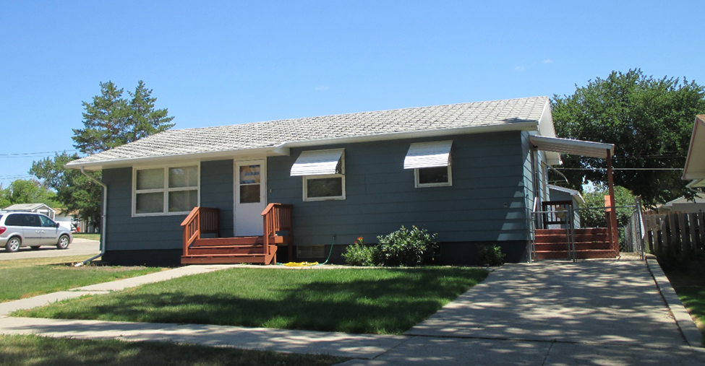
RECORD #5719

LOT SIZE 55’ X 142’ GROUND FLOOR 1000 SQ FT
SINGLE FAMILY 3 BEDROOMS 2 ½ BATHS
ONE STORY BASEMENT 1000 SQ FT
AVERAGE QUALITY AND CONDITION BASEMENT FINISHED REC 500’
BUILT IN 1963+ - DETACHED 2 CAR GARAGE
CENTRAL AIR NATURAL GAS GARAGE 336 SQ FT 2 OPENERS
2014 ROOF FAIR, MASONITE SIDING FAIR
CASEMENT/WOOD WINDOWS POOR
SOLD ON 6/14/17 FOR $70,000 RECORD #5719
ASSESSED IN 2017 AT $95,740
ASSESSED IN 2012 AT $47,570
SOLD ON 6/5/17 FOR $60,000; SOLD IN 2003 FOR $45,000 (ESTATE)

