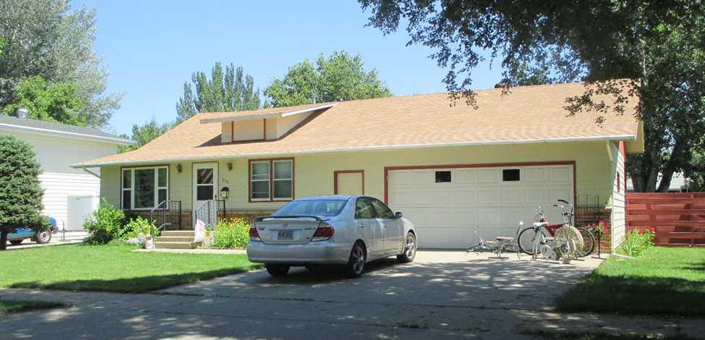
$94,000.00
KRAFT-LOWE
808 1ST AVE WEST, MOBRIDGE
MOBRIDGE MAIN PARK LOTS 11 & 12 BLOCK 20
RECORD #5689

LOT 75’ X 142’ TOTAL LIVING AREA 1153 SQ FT
SINGLE FAMILY 3 BEDROOMS
ONE STORY 1 BATH 5 FIXTURES
AVERAGE QUALITY AND CONDITION BASEMENT 945 SQ FT
BUILT IN 1953 ROOFED PATIO 200 SQ FT
CENTRAL AIR DETACHED 2 CAR GARAGE 624 SQ
2014 ROOF GOOD, FOUNDATION FAIR ATTACHED 2 CAR GARAGE 600 SQ
SPRINKLER SYSTEM, VINYL SIDING
FLOOD ZONE WHEN HEAVY RAINS
SOLD ON 5/23/17
ASSESSED IN 2017 AT $84,930 RECORD #5689
ASSESSED IN 2012 AT $63,295

SOLD IN 1996 FOR $58,000

