$67,000.00
WESTERLUND-FORREST
1002 1ST AVE EAST, MOBRIDGE
MOBRIDGE MAIN PARK LOT 9 & S½ OF LOT 10 BLOCK 10
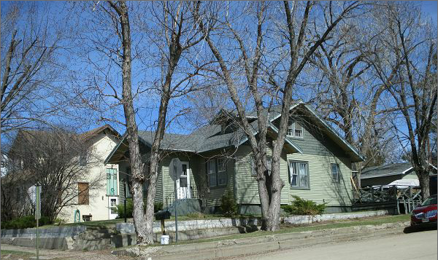
RECORD #5604

LOT SIZE 56.25’ X 142’ TOTAL LIVING AREA 1552 SQ FT
SINGLE FAMILY GROUND FLOOR 960 SQ FT
1 ½ STORY BASEMENT 960 SQ FT
AVERAGE QUALITY AND CONDITION 4 BEDROOMS 1 ¾ BATH
BUILT IN 1910 DETACHED GARAGE 624 SQ FT
AIR COOLED NATURAL GAS WOOD DECK 204 SQ FT
2014 VINYL SIDING, ROOF FAIR OPEN SLAB PORCH 252 SQ FT
WOOD DECK POOR
SOLD ON 1/30/17 FOR $67,000
ASSESSED IN 2016 AT $65,770 RECORD #5604
ASSESSED IN 2012 AT $32,715
SOLD IN 2004 FOR $27,500

