$10,000.00
MAAS-GOSCH
902 2ND AVE EAST, MOBRIDGE
MOBRIDGE MAIN PARK LOT 9 & S ½ OF LOT 10 BLOCK 6
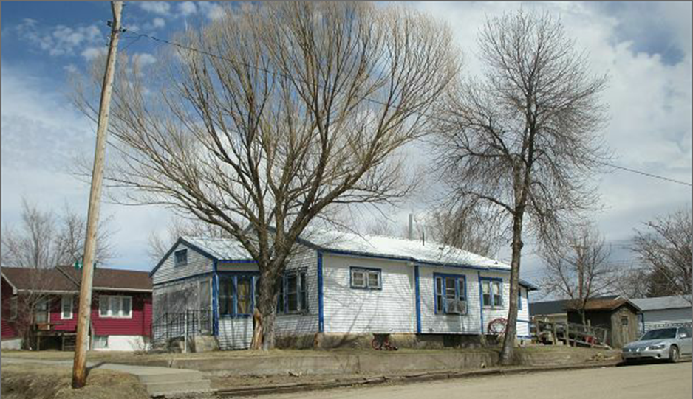
RECORD #5594

LOT SIZE 56.25’ X 142’ GROUND FLOOR 1085 SQ FT
SINGLE FAMILY- ONE STORY 2 BEDROOMS, ONE FULL BATH
AVERAGE QUALITY & CONDITION ONE ¾ BATH, ONE ½ BATH
BUILT IN 1940 BASEMENT 962 SQ FT
2014; METAL ROOF, LAP SIDING POOR 543 FINISHED REC. BASEMENT
WINDOW AIR, FOUNDATION POOR DETACHED GARAGE 312 SQ FT
ALUMINUM WINDOW POOR SOLID WAL PORCH 128 SQ FT
SOLD ON 2/16/18 FOR $10,000
ASSESSED IN 2017 AT $25,020 RECORD #5594
ASSESSED IN 2012 AT $20,855

