$161,000.00
HAAS-AMDAHL
404 9TH ST EAST, MOBRIDGE
MOBRIDGE MAIN PARK LOTS 9 & 10 & S 10’ OF LOT 11 BLOCK 3
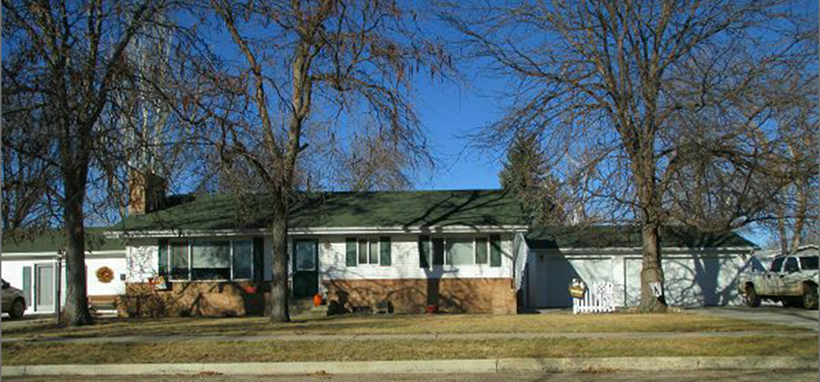
RECORD #5565

LOT SIZE 85’ X 142’ GROUND FLOOR 1483 SQ FT
SINGLE FAMILY ONE STORY BASEMENT 1161 SQ FT
AVERAGE QUALITY & CONDITION 1000 SQ FT FINISHED BSMT
BUILT IN 1970 3 BEDROOMS ABOVE 1 BELOW
2014; CENTRAL AIR 2 UNITS, NATURAL GAS 2 ½ BATHS
CASEMENT/METAL WINDOWS GOOD DETACHED GARAGE 780 SF
2000; CHANGED ATTACHED GARAGE WOOD DECK 403 SQ FT
INTO LIVING QUARTERS; DETACHED GARAGE KNEE WALL PORCH
SOLD ON 8/29/17 FOR $161,000 OPEN SLAB PORCH
ASSESSED IN 2017 AT $174,000
ASSESSED IN 2012 AT $94,965 RECORD #5565

