$170,000.00
SCHLOMER-BRATLAND
1301 SUNSET DR, MOBRIDGE
MOBRIDGE JAY KRAFT 1ST ADDN N15’ OF LOT 11 & S 15’ LOT 12 & VACATED PORTION OF CRESCENT ST BTW LOT 11 & 12
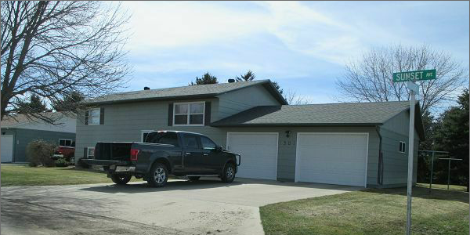
RECORD #5541

LOT SIZE 75’ X 125’ GROUND FLOOR 912 SQ FT
SINGLE FAMILY BASEMENT 912 SQ FT
SPLIT LEVEL 821 SQ FT OF BSMT FINISHED
AVERAGE QUALITY AND CONDITION 4 BEDROOMS 2 UP 2 DOWN
BUILT IN 1975 2 STALL GARAGE ATTACHED 672 SQ FT
NATURAL GAS CENTRAL AIR WOOD DECK 368 SQ FT
2014 ROOF FAIR, WOOD SIDING OPEN SLAB PORCH 200 SQ FT
2 LEVEL WOOD DECK UNDERGROUND SPRINKLER
2008 NEW GARAGE $15,000
SOLD ON 12/05/16 FOR $170,000
ASSESSED IN 2016 AT $134,030 RECORD #5541
ASSESSED IN 2012 AT $85,555

SOLD IN 2012 FOR $136,000, IN 2004 FOR $76,000

