$35,000.00
FEES-WHILE
615 4TH AVE EAST, MOBRIDGE
MOBRIDGE GRAND CROSSING ADDN LOTS 3B &3C BLOCK 61
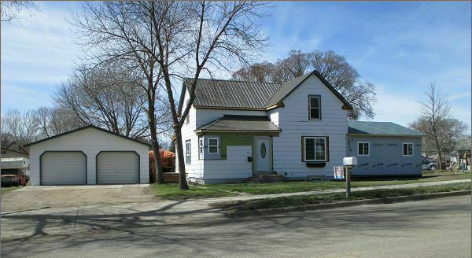
RECORD #5479

LOT SIZE 86’ 140’ GROUND FLOOR 794 SQ FT
SINGLE STORY TOTAL AREA 1079 SQ FT
1 ½ STORY 4 BEDROOMS 2 ½ BATHS
AVERAGE QUALITY AND CONDITION 5 FIXTURES
BUILT IN 1910 BASEMENT 570 SQ FT
HEATED AND COOLED FORCED AIR DETACHED GARAGE 624 SQ FT
2014 BLOWN IN INSULATION, ROOF FAIR WOOD DECK 56 SQ FT
SIDING POOR, BLOCK BASEMENT OPEN SLAB PORCH 322 SQ FT
SOLD ON 8/29/16 FOR $35,000
ASSESSED IN $40,540, IN 2012 AT $23,535 RECORD #5479

SOLD IN 2007 FOR $25,000

