$87,500.00
SWANSON-LAWRENCE
703 6TH AVE WEST, MOBRIDGE
MOBRIDGE GRAND CROSSING ADDN LOT 5 BLOCK 52
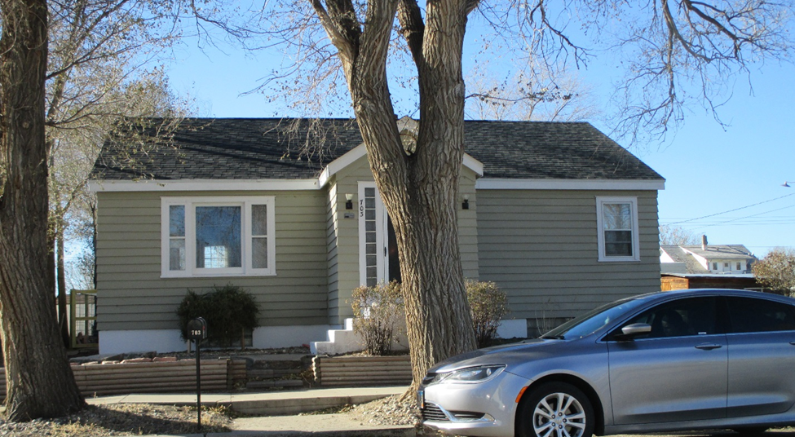
RECORD #5397

LOT SIZE 50’ X 140’ GROUND FLOOR 1047 SQ FT
SINGLE FAMILY ONE STORY 2 BEDROOMS 1 ½ BATHS
AVERAGE QUALITY & CONDITION BASEMENT 999 SQ FT
BUILT IN 1940 10’ X 16’ WOOD DECK
2013; NEW SHINGLES 10’ X 16’ BRICK PATIO
NATURAL GAS CENTRAL AIR
2016; KITHCEN & LIVING REMODEL
NEW FLOORING, INTERIOR DOORS
SOLD ON 9/5/17 FOR $87,500
ASSESSED IN 2017 AT $51,070
ASSESSED IN 2012 AT $22,940 RECORD #5397

