$113,000.00
PEPIN-CHRISTENSON
520 6TH ST WEST, MOBRIDGE
MOBRIDGE GRAND CROSSING ADDN E 60’ OF LOT 7 & E 60’ OF S 40’ OF LOT 8 BLOCK 49
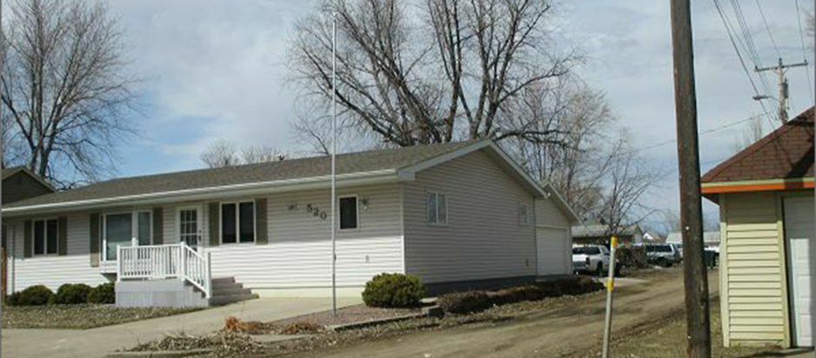
RECORD #5373

LOT SIZE 80’ X 90’ GROUND FLOOR 1536 SQ FT
SINGLE FAMILY-ONE STORY 3 BEDROOMS
AVERAGE QUALITY & CONDITION 2 FULL BATHS, 1 HALF BATH
BUILT IN 1965 200 SQ FT WOOD DECK
2014; ROOF GOOD,WINDOWS GOOD 332 SQ FT OPEN SLAB PORCH
2004; REMODEL GARAGE & ADD BATHROOM
2006; BUILT NEW 28’ X 28’ DETACHED GARAGE
SOLD ON 11/8/17 FOR $113,000
ASSESSED IN 2017 AT $98,190 RECORD #5373
SOLD IN 20158 FOR $112,500, IN 2011 FOR $87,500
ASSESSED IN 2012 $78,120

