$70,000.00
HEPPER-BRIGGS
617 2ND AVE EAST, MOBRIDGE
MOBRIDGE GRAND CROSSING ADDN LOT 2 BLOCK 44
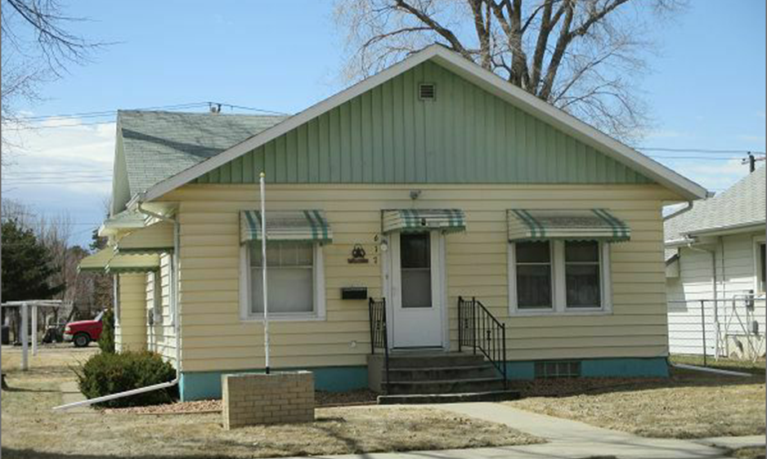
RECORD #5343

LOT SIZE 50’ X 140’ GROUND FLOOR 1044 SQ FT
SINGLE FAMILY ONE STORY 2 BEDROOMS 1 ½ BATH
AVERAGE QUALITY & CONDITION DETACHED GARAGE 240 SQ FT
BUILT IN 1916 CARPORT 240 SQ FT
2014; METAL SIDING, CENTRAL AIR BASEMENT 884 SQ FT
CASEMENT WINDOWS GOOD WOOD DECK 64 SQ FT
POURED FDN WITH SOME CRACKS KNEE WALL PORCH 72 SQ FT
SOLD ON 12/14/17 FOR $70,000
ASSESSED IN 2017 AT $16,410 (ASS. FREEZE)
ASSESSED IN 2012 AT $37,080 RECORD #5343

