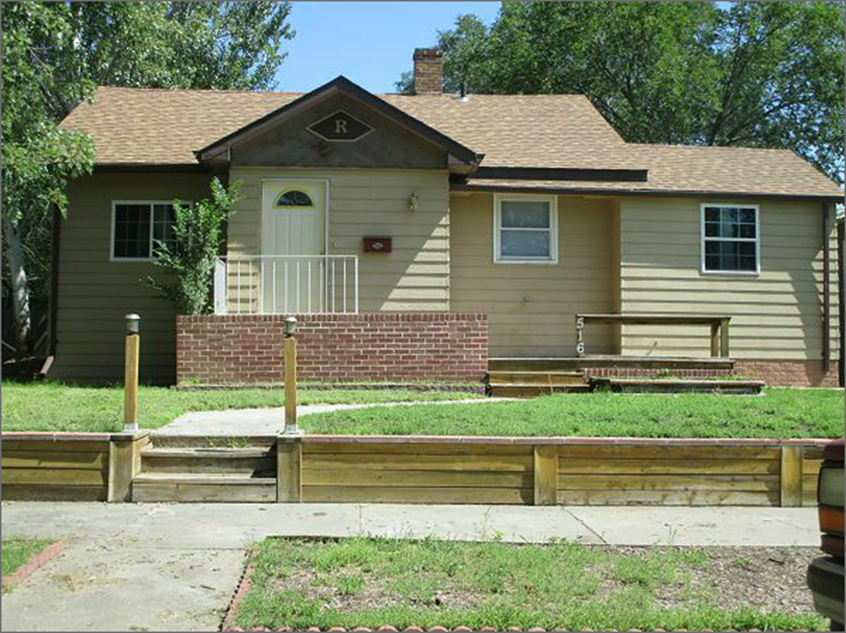
$30,000.00
WALWORTH COUNTY-GOFF
FORCLOSURE-SHERIFF SALE
516 4TH AVE WEST, MOBRIDGE
MOBRIDGE GRAND CROSSING ADDN LOT 10 BLOCK 38
RECORD #5305
LOT SIZE 50’ X 140’ GROUND FLOOR 856 SQ FT
SINGLE FAMILY ONE STORY 2 BEDROOMS 1 ½ BATH
AVERAGE QUALITY AND CONDITION 702 SQ FT BSMT/351 SQ FT FINISHED
BUILT IN 1954 DETACHED GARAGE 30’ X 35’
1994 8’ X 14 ADDN SOLID WALL PORCH 40 SQ FT
1998 CARPORT
1998 20’ X 30’ DRIVEWAY, ENCLOSED GARAGE $4000
2009 FENCE $1800
SOLD ON 7/31/17 FOR $30,000 BOOK 17 PAGE 550
ASSESSED IN 2017 AT $72,510
ASSESSED IN 2015 AT $59,210; SOLD IN 2010 FOR $80,000

