$39,500.00
TB PROPERTIES-PAY PAY
515 4TH AVE WEST
MOBRIDGE GRAND CROSSING ADDN LOT 3 BLOCK 37
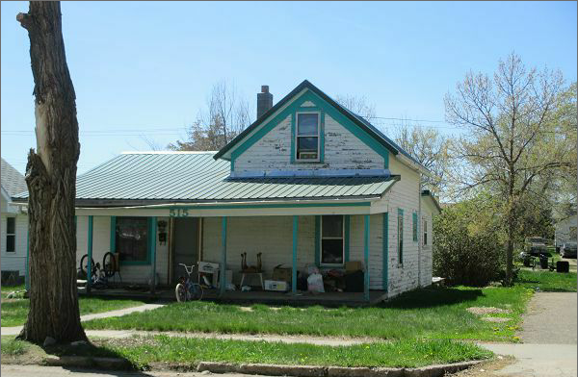
RECORD #5285

LOT SIZE 50’ X 140’ GROUND FLOOR AREA 818 SQ FT
1 ½ STORY SINGLE FAMILY TOTAL AREA 938 SQ FT
BUILT IN 1930 2 BEDROOMS 1 BATH 5 FIXT’S
WORN QUALITY & CONDITION ROOFED PORCH 210 SQ FT
2014; WINDOW AIR, STEEL ROOF WOOD DECK 236 SQ FT
FUEL OIL, LAP SIDING POOR DETACHED GARAGE 216 SQ FT
CASEMENT WINDOWS POOR
REAR WOOD DECK UNUSABLE
SOLD ON 10/14/16 FOR $39,500 RECORD #5285
ASSESSED IN 2016 AT $28,030
SOLD IN 2013 FOR $15,000 ASSESSED IN 2012 AT $16,780

