$35,000.00
TB PROPERTIES-HOYT
314 4TH AVE WEST, MOBRIDGE
MOBRIDGE GRAND CROSSING LOT 10 BLOCK 28
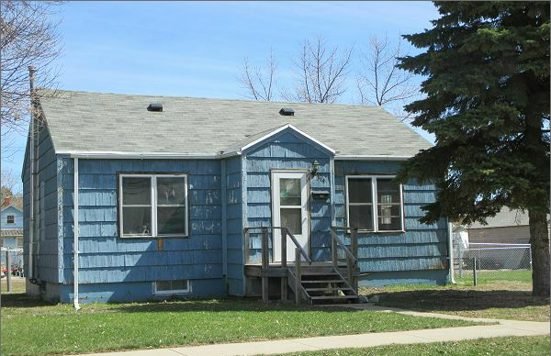
RECORD #5214

LOT SIZE 50’ X 140’ LIVING AREA 744 SQ FT
SINGLE FAMILY 1 BEDROOM 1 BATH
FAIR TO WORN QUALITY AND CONDITION 5 FIXTURES
BUILT IN 1930 + - BASEMENT 744 SQ FT
NATURAL GAS CENTRAL AIR
2014; ROOF POOR, SLATE POOR
WOOD ON BACK POOR
ALUMINUM WINDOW POOR RECORD #5214
SOLD ON 3/10/17 FOR $35,000
ASSESSED IN 2016 AT $13,690
SOLD IN 2011 FOR $8,100, ASSESSED IN 2011 AT $9,580

