$60,000.00
GISI-JOHNSON
EAST GRAND CROSSING
MOBRIDGE GOODMAN’S QUALITY HILL LOTS 5 THRU 9 BLOCK 1
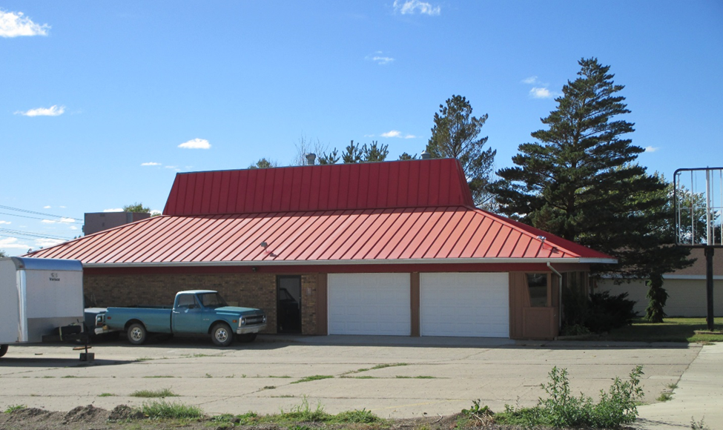
RECORD #5175

5 LOTS 125’ X 140’
COMMERCIAL
ONE STORY
AVERAGE QUALITY AND CONDITION
BUILT IN 1988 + -
BUILDING SIZE 67’ X 29’
SOLD ON 3/4/16 FOR $60,000 BOOK 16 PAGE 732
ASSESSED IN 2016 AT $50,490, IN 2012 AT $75,060
SOLD IN 2013 FOR $55,000
SOLD IN $85,000

