$25,500.00
WALTH-JOHNSON
210 4TH AVE WEST, MOBRIDGE
MOBRIDGE EKLO’S 1ST ADDN LOT 9 BLOCK 3
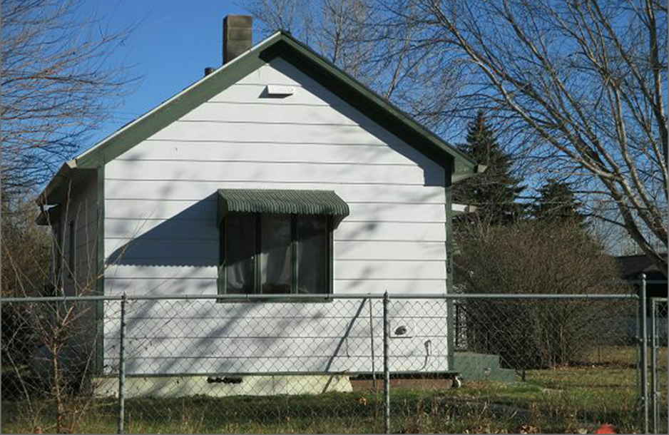
RECORD #4912

LOT SIZE 50’ X 140’ GROUND FLOOR 574 SQ FT
SINGLE FAMILY ONE STORY 1 BEDROOM 1 ¾ BATHS
AVERAGE QUALITY & CONDITION BASEMENT 384 SQ FT ½ BATH
BUILT IN 1940+ - DETACHED GARAGE 304 SQ FT
2014; ROOF GOOD, GARAGE ROOF POOR
SOLD ON 9/8/2017 FOR $25,500
ASSESSED IN 2017 AT $24,570
SOLD IN 2005 FOR $7,000 RECORD # 4912
ASSESSED IN 2012 AT $11,530

