$100,000.00
HEID-ROESLER
1016 4TH AVE EAST, MOBRIDGE
MOBRIDGE BROWN’S 1ST ADDN LOT 9 BLOCK 1
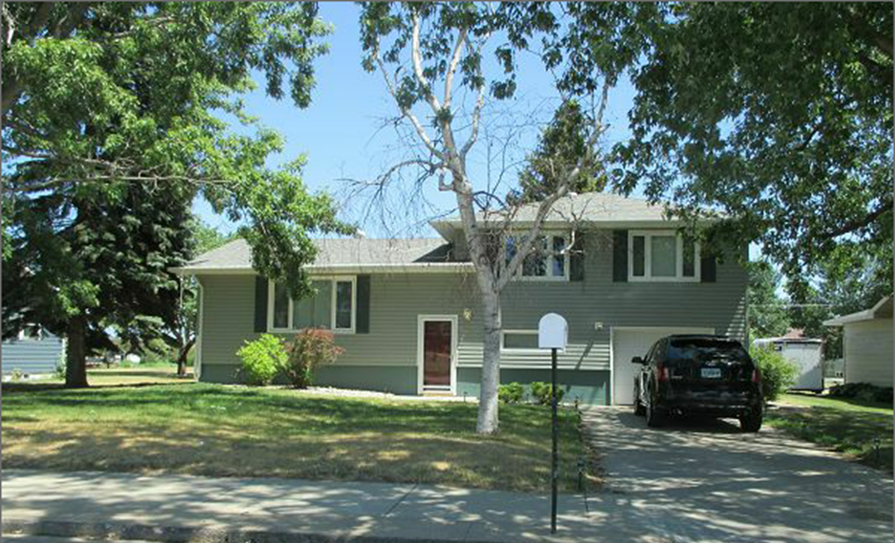
RECORD #4767

LOT SIZE 78’ X 150’ TOTAL LIVING AREA 1392 SQ FT
SINGLE FAMILY SPLIT LEVEL 1ST FLOOR 1152 SQ FT
AVERAGE QUALITY AND CONDITION 3 BEDROOMS 1 BATH
BUILT IN 1963 14’ X 24’ BUILT IN GARAGE
CENTRAL AIR NATURAL GAS 14’ X 20’ WOOD DECK
2014; ROOF GOOD, VINYL SIDING 2007 10’ X 14’ SHED
CASEMENT/METAL WINDOWS GOOD SPRINKLER WYSTEM
SOLD ON 7/6/17 FOR $100,000 (NOT ON OPEN MARKET)
ASSESSED IN 2017 AT $118,330 SINGLE STORY GAS FIREPLACE
SOLD IN 2013 FOR $125,000
ASSESSED IN 2012 AT $52,135 RECORD #4767

