$98,000.00
KUHN-SAUER
518 CRESCENT, MOBRIDGE
MOBRIDGE BEL-AIRE 1ST ADDN LOT 1 BLOCK 5
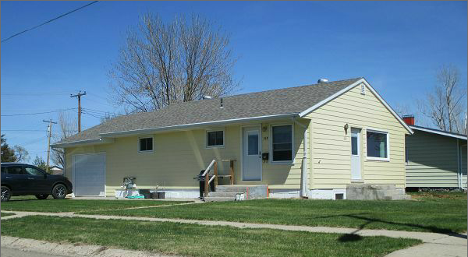
RECORD #4717

LOT SIZE 65’ X 130’ GROUND FLOOR 864 SQ FT
ONE STORY SINGLE FAMILY 2 BEDROOMS 1 BATH 5 FIXT’S
BUILT IN 1959 BASEMENT 864 SQ FT
AVERAGE QUALITY & CONDITION 432 SQ FT FIN. REC.
2004 SPRINKLER SYSTEM ATTACHED GARAGE 336 SQ FT
2006 RESIDE, NEW WINDOW $4000
2010 PRIVACY FENCE, 2011 REMODEL KITCHEN
CENTRAL AIR, NATURAL GAS, EGRESS SOUTH & EAST
SOLD ON 4/18/17 FOR $98,000
ASSESSED IN 20016 AT $75,870 RECORD #4717
ASSESSED IN 2012 AT 425,545

SOLD IN 2010 FOR $43,000

