$65,000.00
KELLER-M & C RENTALS
516 12TH ST WEST, MOBRIDGE
MOBRIDGE BEL AIRE 1ST ADDITION LOT 31 BLOCK 2
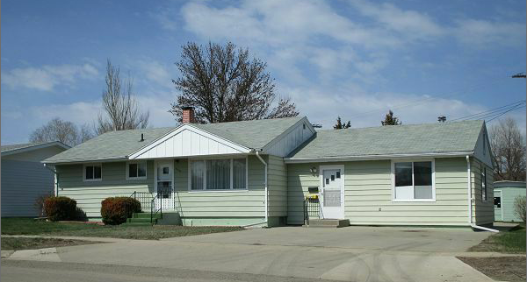
RECORD #4716

LOT SIZE 115’ X 86.25 GROUND FLOOR 1450 SQ FT
SINGLE FAMILY ONE STORY 2 BEDROOMS 1 BATH
AVERAGE QUALITY AND CONDITION BASEMENT 864 SQ FT
BUILT IN 1958 FINISHED 1 BEDROOM 1 BATH
CENTRAL AIR NATURAL GAS 8’ X 8’ WOOD SHED
2014; SHINGLED ROOF GOOD, VINYL SIDING FIREPLACE
POURED FOUNDATION GOOD 12’ X 10’ METAL SHED
CASEMENT WINDOWS FAIR NO ALLEY ACCESS
SOLD ON 3/02/17 FOR $40,000 BOOK 17 PAGE 143
ASSESSED IN 2016 AT $40,940, IN 2012 AT $39,650 RECORD #4716
SOLD ON 5/15/17 FOR $65,000 BOOK 17 PAGE 306

