$219,000.00
HEIL-KESSLER
1009 10TH AVE WEST, MOBRIDGE
MOBRIDGE ACADEMY LOT 2 BLOCK 5
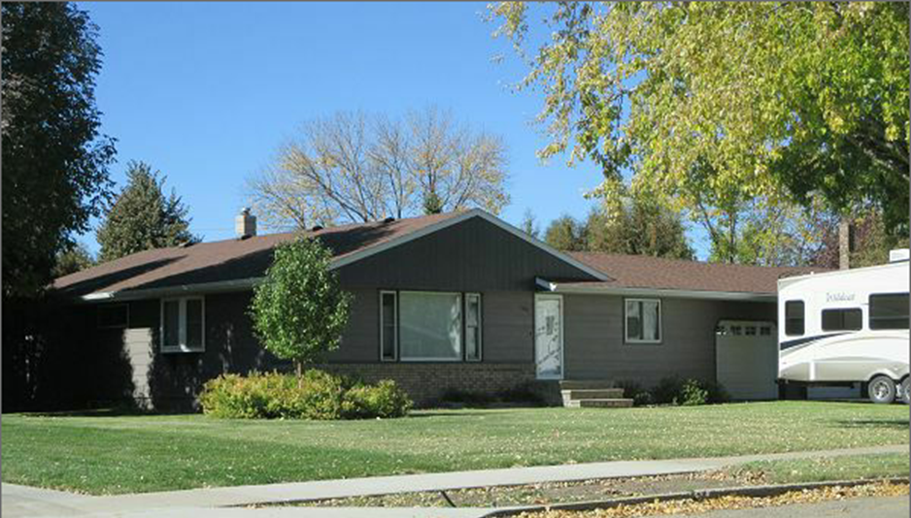
RECORD #4691

LOT SIZE 100’ X 150’ GROUND FLOOR 1456 SQ FT
SINGLE FAMILY 1 STORY 3 BEDROOMS GROUND FLOOR
AVERAGE QUALITY & CONDITION 3 BATHS 1 SINGLE FIXTURE
YEAR BUILT 1962 BASEMENT 1288 SQ FT
SPRINKLER SYSTEM 1200 SQ FT FINISHED LIVING
2003; FINISHED BASEMENT 1 BEDROOM IN BASEMENT
2009; INTERIOR REMODEL, 2008 ROOF REPLACED
2014; ROOF GOOD, 3 EGRESS WINDOWS
NATURAL GAS, CENTRAL AIR
SOLD ON 8/10/17 FOR $219,000 ATTACHED GARAGE 672 SQ FT
ASSESSED IN 2017 AT $162,020 WOOD DECK 37 SQ FT
SOLD IN 1994 FOR $75,000 OPEN SLAB PORCH 130 SQ FT
ASSESSED IN 2012 AT $101,390 RECORD #4691

