$90,000.00
KARST-GOODMAN
6302 4TH AVE. MOBRIDGE
SELBY PLAINVIEW 1ST, LOT 2, BLOCK 4
RECORD #4614
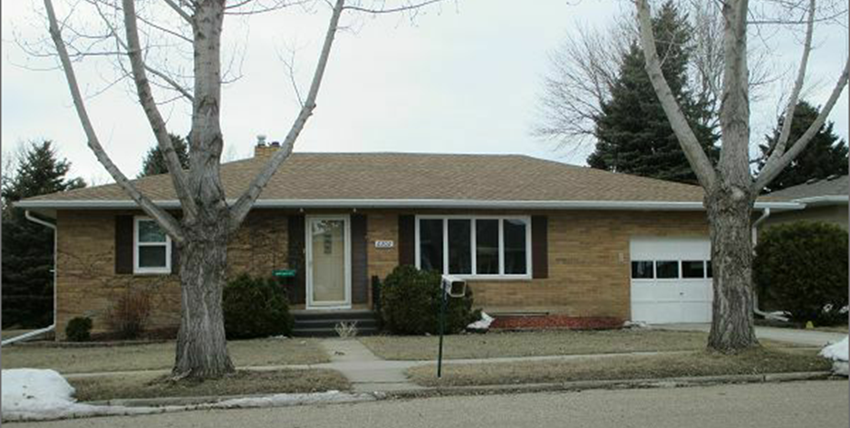
LOT SIZE 39’ X 110’ GROUND FLOOR 1452 SQ FT
SINGLE FAMILY ONE STORY BASEMENT 1312 SQ FT
AVERAGE QUALITY & CONDITION BSMT 984 SQ FT FIN REC
BUILT IN 1960 2 BATHS
CENTRAL AIR NATURAL GAS 2 BEDROOMS ABOVE 2 BELOW
SOLD ON 2/5/18 FOR $90,000 WOOD DECK 264 SQ FT
ASSESSED IN 2018 AT $101,660 ATTACHED GARAGE 308 SQ FT
ASSESSED IN 2014 AT $72,235 DETACHED GARAGE 988 SQ FT
DETACHED GARAGE 544 SQ FT

RECORD #4614

