$60,000.00
MOXLEY-HUBER
510 EAST BANGOR ST. SELBY
SELBY OVERHOLSER ADDITION LOTS 5 & 6 BLOCK 5
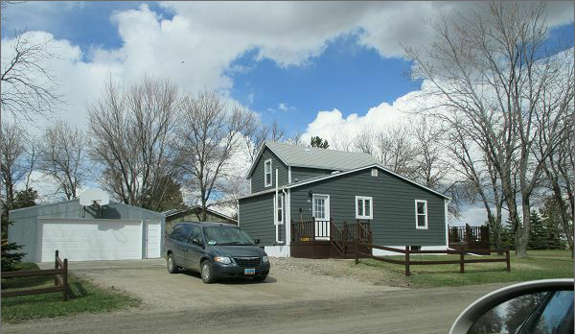
RECORD #4570

LOT SIZE 100’ X 140’ 846 SQ FT MAIN
SINGLE FAMILY 1038 TOTAL SQ FT
1 ½ STORY BASEMENT 846 SQ FT
AVERAGE QUALITY AND CONDITION 423 SQ FT FINISHED
BUILT IN 1910 3 BEDROOMS 1 ¾ BATH
CENTRAL AIR NATURAL GAS 8 FIXTURES
2015 ROOF GOOD; BOX BAY EAST I BEDROOM 1 BATH BSMT.
SOLD ON 12/15/16 FOR $60,000 24’X30’ SQ FT DET. GARAGE
ASSESSED IN 2017 AT $52,360 223 SQ FT WOOD DECK
ASSESSED IN $20,700 RECORD # 4570
SOLD IN 2012 FOR $22,500 BOOK 12 PAGE 905

