$15,000.00
KIGHTLINGER - D & K BOHLE LLC
2910 OVERHOLSER, SELBY
SELBY OVERHOLSER ADDN LOT 1 BLOCK 5
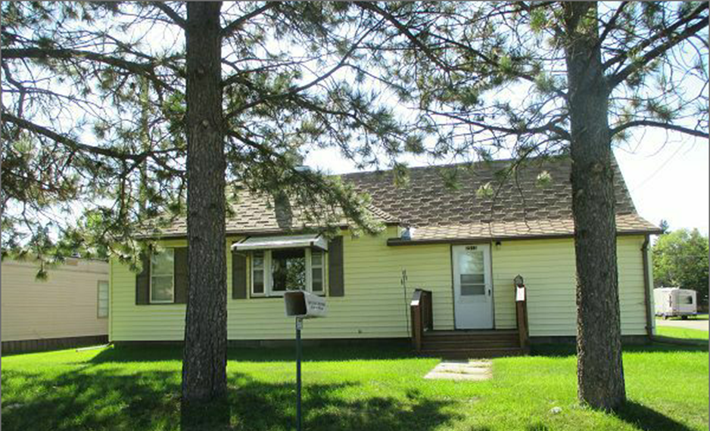
RECORD #4567
LOT SIZE 50’ X 140’ GROUND FLOOR 942 SQ FT
SINGLE FAMILY ONE STORY 2 BEDROOMS 1 ½ BATHS
AVERAGE QUALITY AND CONDITION 942 SQ FT BASEMENT
BUILT IN 1920 + - DETACHED GARAGE 352 SQ FT
2015; ROOF GOOD, VINYL SIDING
METAL WINDOWS POOR
2014; NEW NATURAL GAS CENTRAL AIR
1996; BOWED BASEMENT WALL REPAIRED
1994; STEEL ROOF ON GARAGE
SOLD ON 8/4/17 FOR $15,000 RECORD #4567
ASSESSED IN 2017 AT $29,970
ASSESSED IN 2012 AT $17,005

