$35,000.00
WOLF-THORSTENSON
206 EAST SCRANTON, SELBY
SELBY MILW. LAND CO’S 1ST ADDN W ½ OF LOTS 4, 5 & 6 BLOCK 22
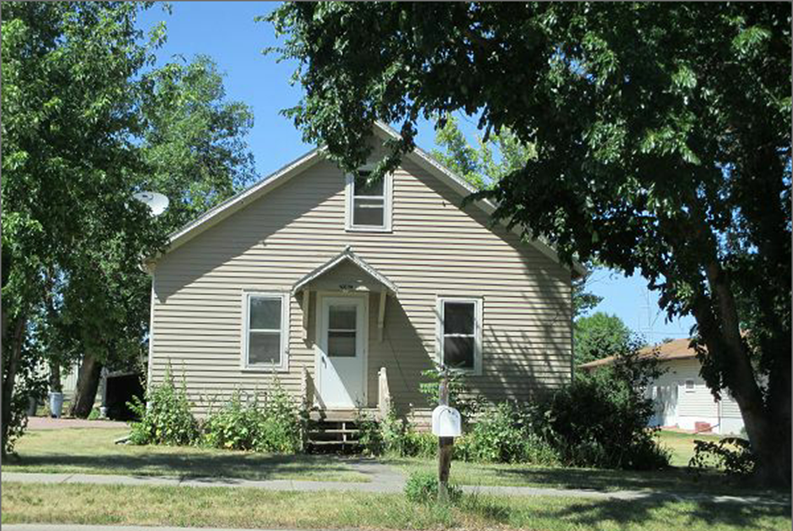
RECORD #4313
LOT SIZE 70’ X 150’ GROUND FLOOR 780 SQ FT
SINGLE FAMILY TOTAL AREA 1014 SQ FT
ONE STORY ATTIC 2 BEDROOMS 1 BATH
AVERAGE QUALITY AND CONDITION BASEMENT 780 SQ FT
BUILT IN 1920 DETACHED GARAGE 280 SQ FT
2015; ROOF- GOOD, WOOD LAP SIDING-FAIR SOLID WALL PORCH 81 SQ FT
2012 14’X22’ GARAGE ADDITION $2,500 2001 6’ X 20’ GARAGE ADDITION
2010; 12’ X 12 DECK
SOLD ON 6/29/17 FOR $35,000
ASSESSED IN 2017 AT $37,350
SOLD IN 2000 FOR $19,000 RECORD #4313
ASSESSED IN 2012 AT $13,860

