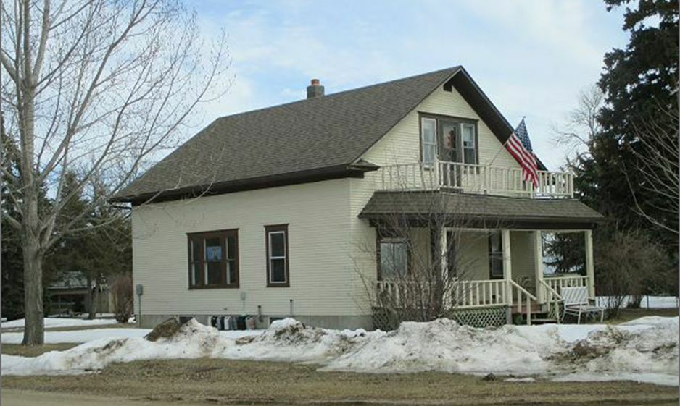
THIS SALE AND SALE #4151 ARE ONE COMBINED SALE.

$50,000.00
FERGUSEN-FRONING
2400 3RD AVE. JAVA
JAVA 1ST ADDN TO PAYNE’S PLAT LOTS 1 & 2 BLOCK 4
RECORD #4152

LOT SIZE 100’ X 140’ GROUND FLOOR 832 SQ FT
1 ½ STORY SINGLE FAMILY TOTAL LIVING AREA 1248 SQ FT
BUILT IN 1920 + - 2 BEDROOMS 1 BATH
ROOFED PORCH 176 SQ FT
SOLID WALL PORCH 96 SQ FT
SOLD WITH #4151 ON 2/2/18 FOR $50,000
ASSESSED IN 2017 AT $10,945
ASSESSED IN 2012 AT $9,190 RECORD #4152

