$51,000.00
BARZ-JUST B’CUS LLC
603 9TH AVE E. MOBRIDGE
LOTS A1 & A11 IN TRACT A & B IN SE4SW4 20-124-79
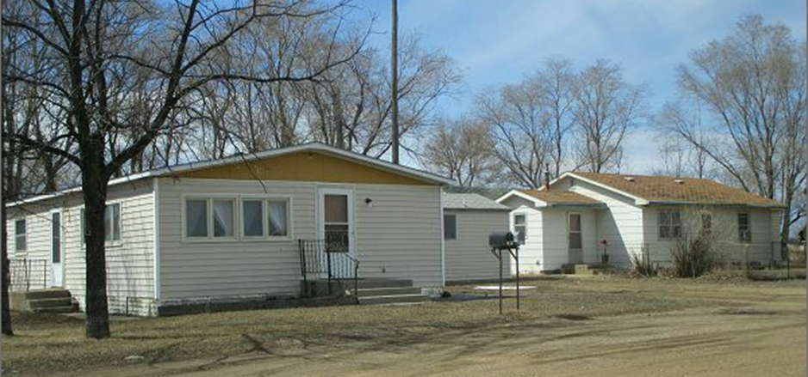
RECORD #3593

LOT SIZE .98 ACRES MH 3 BEDROOMS 1 ½ BATHS
1971 24’ X 50’ CHAMP. MH HOUSE 2 BEDROOMS 1 BATH
1930’S 1028 SQ FT HOUSE 20’ X 22’ SHED
SOLD ON 11/30/2017 FOR $51,000
ASSESSED IN 2017 AT $38,275
ASSESSED IN 2012 AT $33,285 RECORD #3593

