$260,000.00
TISDALL-SCHELL
2910 10TH AVE WEST, MOBRIDGE
LOTS 2A,3A,4A & 5A, 1ST SUBD. OF GOVT. LOT 2
IN NW4 OF STR 18-124-79
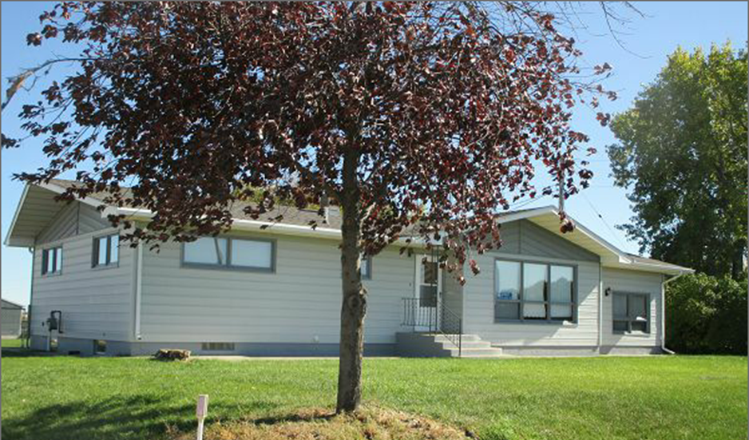
RECORD #3486

LOT SIZE 4 ACRES GROUND FLOOR 2036 SQ FT
ONE STORY SINGLE FAMILY 3 BEDROOMS 2 BATHS
AVERAGE QUALITY & CONDITION BASEMENT 1286 SQ FT
BUILT IN 1965 FINISHED LIVING 1200 SQ FT
2015; NATURAL GAS, CENTRAL AIR WOOD DECK 252 SQ FT
EGRESS ON NORTH, METAL SIDING 3 SEASON COVERED DECK
WOOD/METAL WINDOWS POOR 390 SQ FT ADDITION
SLIDING GLASS DOOR 1200 SQ FT STORAGE/GARAGE
LEAN TO TYPE 3 SEASON PORCH 1440 SQ FT BUILDING/BARN
SOLD ON 8/9/17 FOR 260,000 ESTATE AUCTION
ASSESSED IN 2017 AT $190,740
ASSESSED IN 2012 AT $113,780 SOLD IN 2001 FOR $145,000

