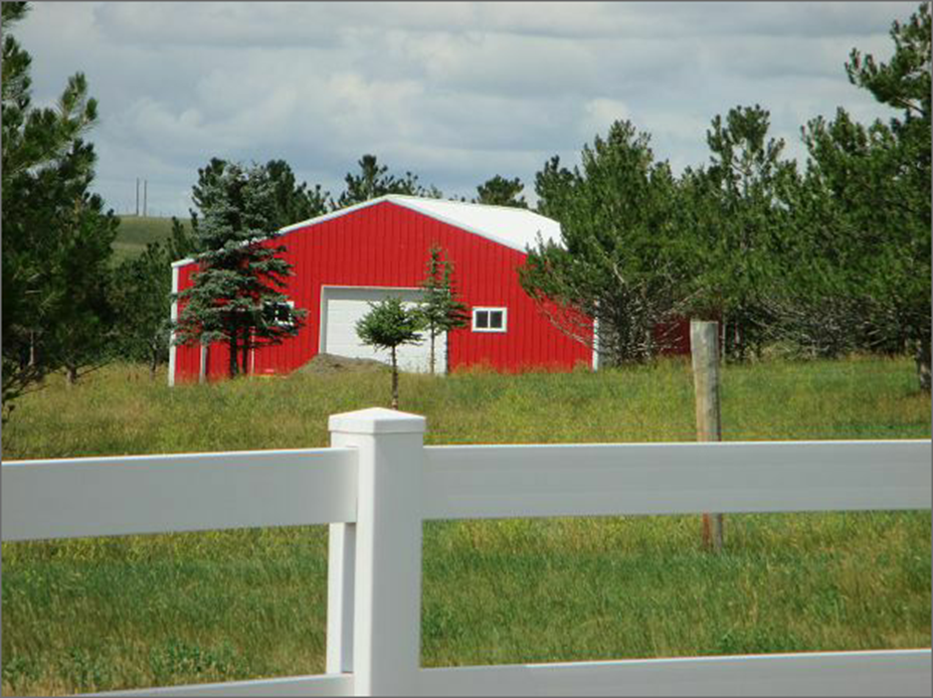
RECORD #3458
HAGGE-OSTER
28730 127TH ST, MOBRIDGE
DETACHED GARAGE 1,216 SQ FT

