$166,000.00
BLUE BLANKET CREEK LODGE-MOODY
29282 131ST ST. GLENHAM
TRACT 2 IN TURNER ADDN SE4SE4 6-123-78
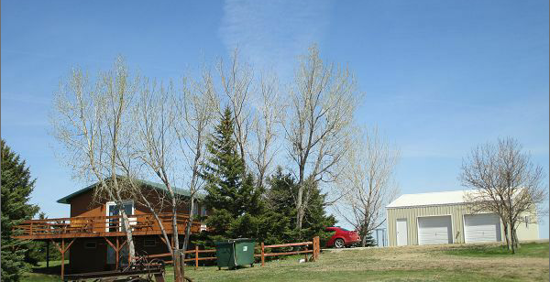
RECORD #2279

LOT SIZE .58 ACRES GROUND FLOOR 912 SQ FT
SINGLE FAMILY 2 BEDROOMS 2 BATH
ONE STORY FINISHED BASEMENT 912 SQ FT
BUILT IN 1985 WOOD DECK 600 SQ FT
AVERAGE QUALITY AND CONDITION DETACHED GARAGE 768 SQ FT
GARAGE BUILT IN 2000 BASEBOARD ELECTRIC HEAT
2007; STEEL ROOF, BASEMENT FLOOR 8 FIXTURES
2009 REMODEL $20,000
SOLD ON 8/3/16 FOR $166,000
ASSESSED IN 2016 AT $101,055 RECORD #2279
SOLD IN 2004 FOR $69,000
ASSESSED IN 2012 AT $93,985

