$41,600.00
BAKER-FRANK
4506 3RD AVE. SELBY
SELBY ORIGINAL LOT 4 BLOCK 3
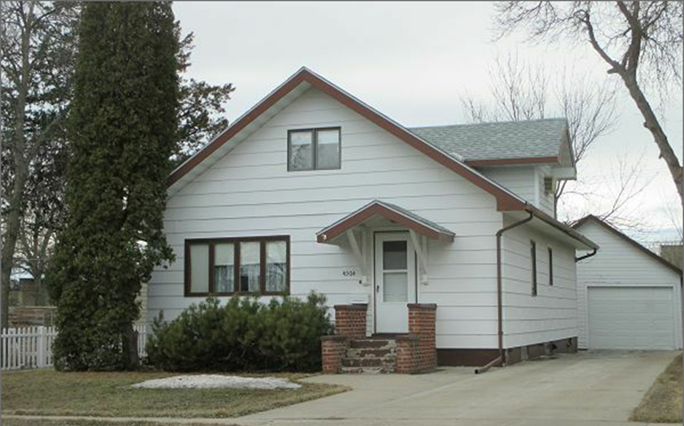
RECORD #4417

LOT SIZE 50’ X 140’ GROUND FLOOR 988 SQ FT
1 ½ STORY SINGLE FAMILY TOTAL AREA 1482 SQ FT
AVERAGE QUALITY & CONDITION 4 BEDROOMS
BUILT IN 1932 1 FULL BATH, ONE ¾ BATH
2015; FOUNDATION GOOD, SIDING POOR ONE ½ BATH
CENTRAL AIR, NATURAL GAS BASEMENT 988 SQ FT
SOLD ON 12/28/17 FOR $41,600 494 SQ FT FIN. REC. IN BSMT.
ASSESSED IN 2017 AT $46,280 DETACHED GARAGE 324 SQ FT
ASSESSED IN 2012 AT $21,375 OPEN SLAB PORCH 324 SQ FT

